Face Recognition using Deep Learning CNN

Submitted by:-

|  |  |
| --- | --- |
| Sr.no. | Name |
| 01 | Ramesh Kumar |
| 02 | Ravi Reo |
| 03 | Maneesh Kumar |

Submitted to:-

A.K Sinha Sir

Introduction

Face recognition is the identification of humans by the unique characteristics of their faces. Face recognition technology is the least intrusive and fastest bio-metric technology. This project deals with the correct matching and identifying of the faces of different public personalities with their names.

Data Description

The data contains cropped face images of 04 people divided into Training and testing. We will train the CNN model using the images in the Training and Testing folder.



Creating the CNN model for face recognition

I have created a CNN model with

* 2 hidden layers of convolution
* 2 hidden layers of max pooling
* 1 layer of flattening
* 1 Hidden ANN layer
* 1 output layer with 04-neurons (one for each face)



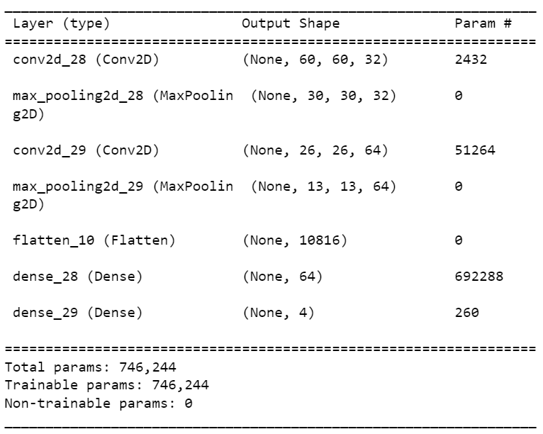

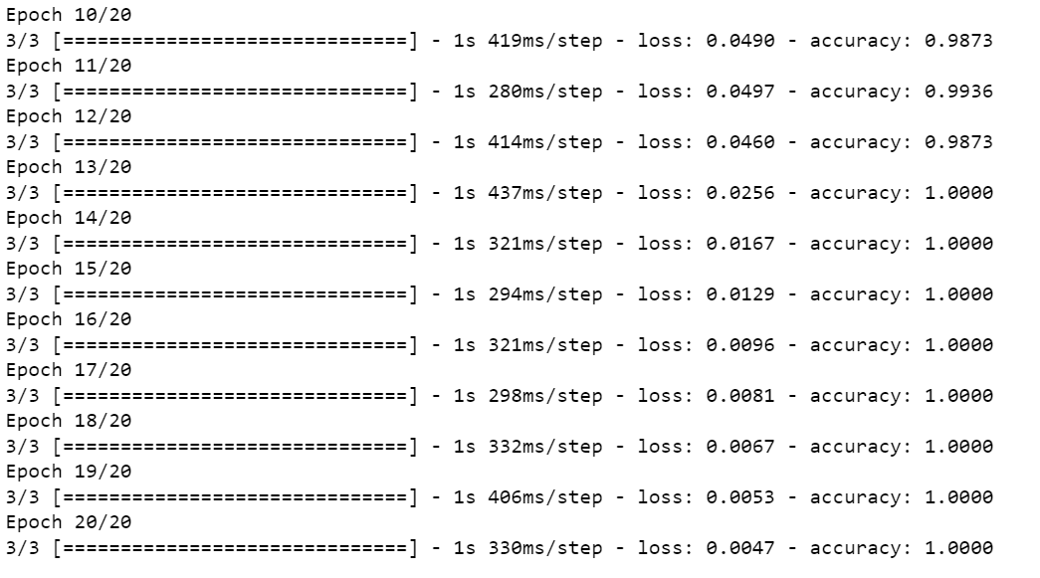 Testing the CNN model on images

Using any one of the images from the testing data folder, we can check if the model is able to recognize the face.



Conclusion

The model identified the faces of people with 100% accuracy.

